**Creating Microservices for Account and Loan**

**Account Structure:**

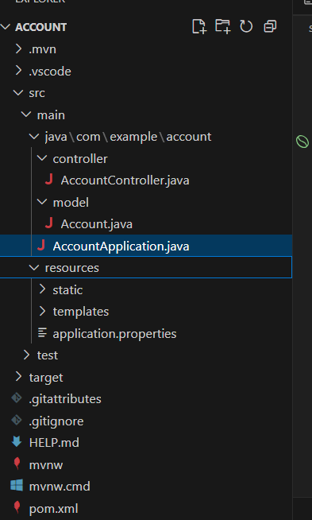

**AccountController:**

package com.example.account.controller;

import org.springframework.web.bind.annotation.GetMapping;

import org.springframework.web.bind.annotation.PathVariable;

import org.springframework.web.bind.annotation.RestController;

import com.example.account.model.Account;

@RestController

public class AccountController {

    public AccountController() {

        System.out.println("AccountController created!");

    }

    @GetMapping("/accounts/{number}")

    public Account getAccountByNumber(@PathVariable String number) {

        System.out.println("Controller method called with number: " + number);

        return new Account(number, "savings", 234343.0);

    }

}

**Account:**

package com.example.account.model;

public class Account {

    private String number;

    private String type;

    private Double balance;

    public Account() {}

    public Account(String number, String type, Double balance) {

        this.number = number;

        this.type = type;

        this.balance = balance;

    }

    public String getNumber() { return number; }

    public void setNumber(String number) { this.number = number; }

    public String getType() { return type; }

    public void setType(String type) { this.type = type; }

    public Double getBalance() { return balance; }

    public void setBalance(Double balance) { this.balance = balance; }

}

**AccountApplication:**

package com.example.account;

import org.springframework.boot.SpringApplication;

import org.springframework.boot.autoconfigure.SpringBootApplication;

@SpringBootApplication

public class AccountApplication {

    public static void main(String[] args) {

        SpringApplication.run(AccountApplication.class, args);

    }

}

**Output:**

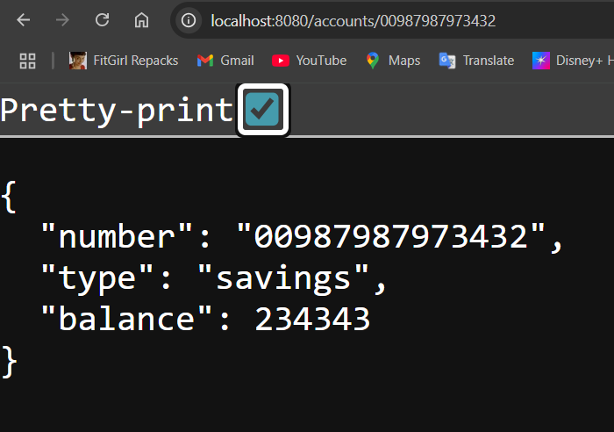

**Loan Structure:**

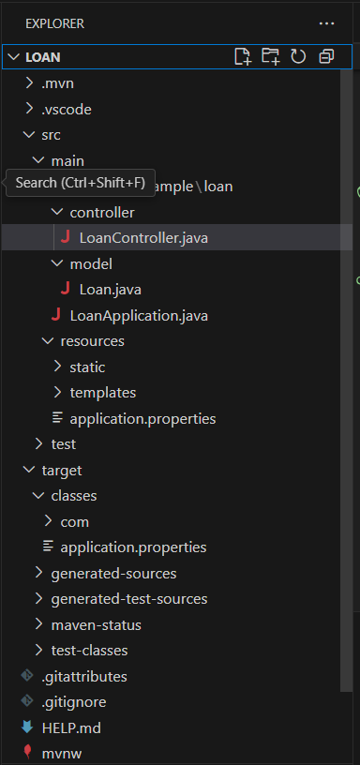

**LoanController:**

package com.example.loan.controller;

import com.example.loan.model.Loan;

import org.springframework.http.ResponseEntity;

import org.springframework.web.bind.annotation.*;

@RestController

@RequestMapping("/loans")

public class LoanController {

    @GetMapping("/{number}")

    public ResponseEntity<Loan> getLoanDetails(@PathVariable String number) {

        Loan loan = new Loan();

        loan.setNumber("H00987987972342");

        loan.setType("car");

        loan.setLoan(400000);

        loan.setEmi(3258);

        loan.setTenure(18);

        return ResponseEntity.ok(loan);

    }

}

**Loan:**

package com.example.loan.model;

public class Loan {

    private String number;

    private String type;

    private double loan;

    private double emi;

    private int tenure;

    public Loan() {}

    public Loan(String number, String type, double loan, double emi, int tenure) {

        this.number = number;

        this.type = type;

        this.loan = loan;

        this.emi = emi;

        this.tenure = tenure;

    }

    public String getNumber() {

        return number;

    }

    public void setNumber(String number) {

        this.number = number;

    }

    public String getType() {

        return type;

    }

    public void setType(String type) {

        this.type = type;

    }

    public double getLoan() {

        return loan;

    }

    public void setLoan(double loan) {

        this.loan = loan;

    }

    public double getEmi() {

        return emi;

    }

    public void setEmi(double emi) {

        this.emi = emi;

    }

    public int getTenure() {

        return tenure;

    }

    public void setTenure(int tenure) {

        this.tenure = tenure;

    }

}

**LoanApplication:**

package com.example.loan;

import org.springframework.boot.SpringApplication;

import org.springframework.boot.autoconfigure.SpringBootApplication;

@SpringBootApplication

public class LoanApplication {

    public static void main(String[] args) {

        SpringApplication.run(LoanApplication.class, args);

    }

}

**Output:**

